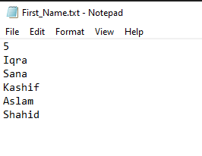

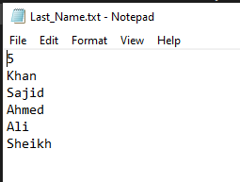

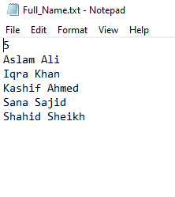

**Code:**

#include<iostream>

#include<fstream>

using namespace std;

char ** read(ifstream& f, int& s);

char ** full_name(char ** a, char ** b, int c);

void sort(char ** a, int b);

void write(char ** a, int b);

char ** del(char ** a, int b);

int main()

{

int size;

ifstream fin;

fin.open("First_Name.txt");

char **first = read(fin, size);

fin.close();

fin.open("Last_Name.txt");

char **last = read(fin, size);

fin.close();

char ** full = full_name(first, last, size);

sort(full, size);

write(full, size);

first = del(first, size);

last = del(last, size);

full = del(full, size);

system("pause");

return 0;

}

char ** read(ifstream& f, int& s)

{

char a[2];

f >> s;

f.getline(a, 2);

char ** x = new char*[s];

for (int i = 0; i < s; ++i)

{

x[i] = new char[7];

}

for (int i = 0; i < s; ++i)

{

f.getline(x[i], 7);

}

return x;

}

char ** full_name(char ** a, char ** b, int c)

{

int z = 0;

char ** x = new char*[c];

for (int i = 0; i < c; ++i)

{

x[i] = new char[14];

}

for (int i = 0; i < c; ++i)

{

int y = 0;

for (int j = 0; j < 14; ++j)

{

if (j >= 7)

{

x[i][j] = b[z][y];

++y;

}

else

{

x[i][j] = a[i][j];

}

}

++z;

}

for (int k = 0; k < c; ++k)

{

char t;

for (int i = 0; i < c; ++i)

{

for (int j = 0; j < 14 - 1; ++j)

{

if (!(x[i][j] >= 'A' && x[i][j] <= 'Z' || x[i][j] >= 'a' && x[i][j] <= 'z' || x[i][j] == '\0'))

{

if (x[i][j + 1] >= 'A' && x[i][j + 1] <= 'Z' || x[i][j + 1] >= 'a' && x[i][j + 1] <= 'z' || x[i][j + 1] == '\0')

{

t = x[i][j];

x[i][j] = x[i][j + 1];

x[i][j + 1] = t;

}

}

}

}

}

for (int i = 0; i < c; ++i)

{

for (int j = 0; j < 14; ++j)

{

if (x[i][j] == '\0')

{

x[i][j] = ' ';

break;

}

}

}

return x;

}

void sort(char ** a, int b)

{

char *t;

for (int j = 0; j < b; ++j)

{

for (int i = 0; i < b - 1; ++i)

{

if (a[i][0]>a[i + 1][0])

{

t = a[i];

a[i] = a[i + 1];

a[i + 1] = t;

}

}

}

}

void write(char ** a, int b)

{

ofstream fout;

fout.open("Full_Name.txt");

if (fout.is_open())

{

fout << b << endl;

for (int i = 0; i < b; ++i)

{

fout << a[i] << endl;

}

}

}

char ** del(char ** a, int b)

{

for (int i = 0; i < b; ++i)

{

delete[]a[i];

}

delete[]a;

a = 0;

return a;

}